ISSACK WAITHAKA
cs-sa07-24085

Introduction to computer forensics for windows
- Forensics involves gathering evidence of activities performed on a computer.
- Forensic artifacts are essential pieces of information that provide evidence of human activity
- Windows saves your activities to make the computer more personalized

Questions
1.
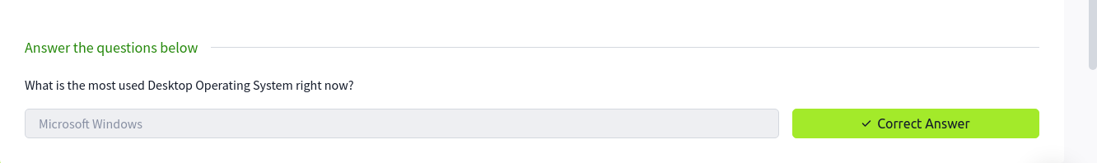

Windows Registry and Forensics
- Windows registry is a collection of databases that contains the system’s configuration data, which could be about the hardware, software or data about recent used files.
- Windows Registry consists of keys and values.
- Windows Registry has five root keys which include:
- HKEY_CURRENT_USER -
- HKEY_USERS
- HKEY_LOCAL_MACHINE
- HKEY_CLASSES_ROOT
- HKEY_CURRENT_CONFIG
- We can find these keys on regedit.exe

Questions
1.
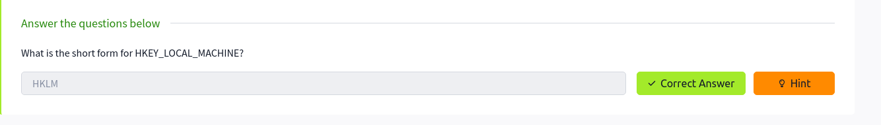

Accessing registry hives offline
- Majority of hives are located in c:\windows\System32\Config\……
- There is also another two hives containing user information that can be found in user profile directory.
- The transaction log is also a vital source of forensic data. It can be considered as the journal of the changelog of the registry hive.
- They are stored as a .LOG file and are located in c:windows\system32\config

Questions
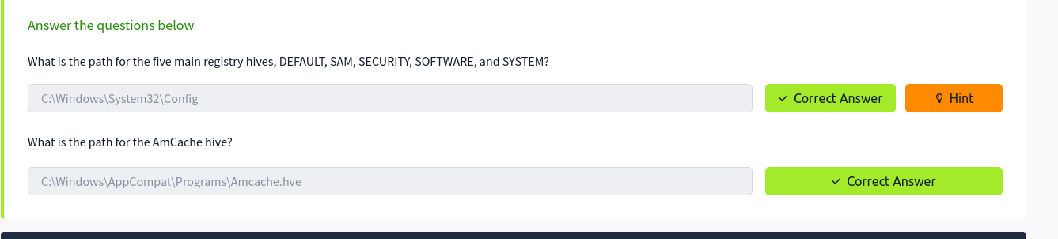

Data Acquisition
- Acquisition involves making a copy of required data or use the image of the system and perform forensics on it.
- KAPE is a live data acquisition tool that which can be used to acquire registry data.
- Autopsy allows us to either acquire data from live systems or from disk image.
- FTK imager works like autopsy but this allows us to mount the disk image or drive in FTK imager

Exploring Windows Registry
- Registry viewer loads one hive at a time
- Registry explorer, can load multiple hive simultaneously and add data from transaction logs into the hive.
- RegRipper a tool that takes registry as input and output report that extracts data from some of the important keys.

System information and System Account
- We can find the OS version from the data that was pulled through
Software\Microsoft\windows NT\currentVersion
- Current Control sets are hives containing machines configuration data used for controlling system startup
- location is system\controlset...
- Current control is set when machine is live.
- We can find the computer name from
SYSTEM\CurrentControlSet\Control\ComputerName\computerName
- To find the time zone location
SYSTEM\CurrentControlSet\Control\TimeZoneInformation
- To find network Interface
SYSTEM\CurrentControlSet\Services\Tcpip\Parameters\Interfaces
- Information about services are found inSYSTEM\CurrentControlSet\Service

Questions
1.
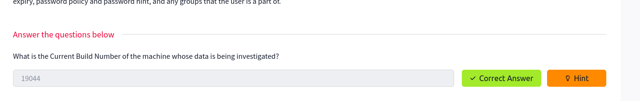
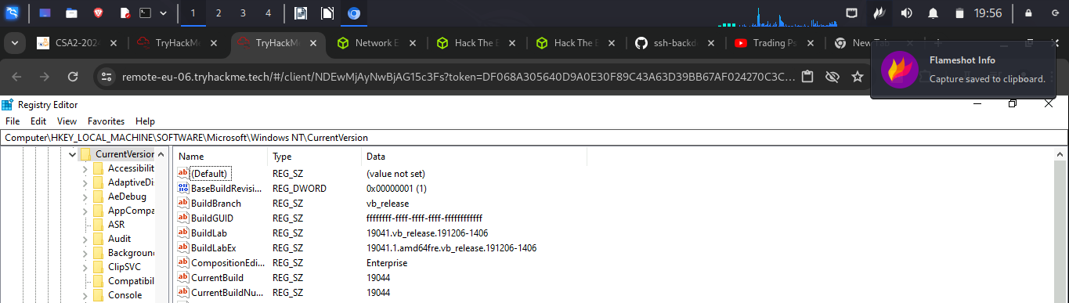
2.
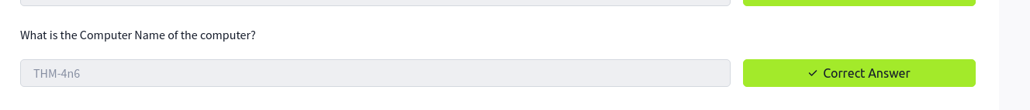
3.
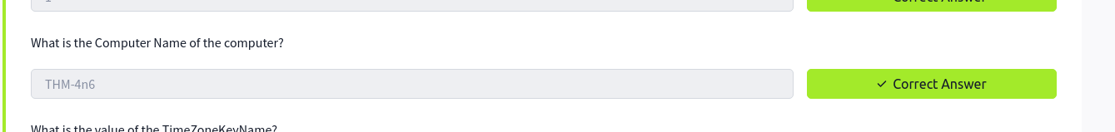
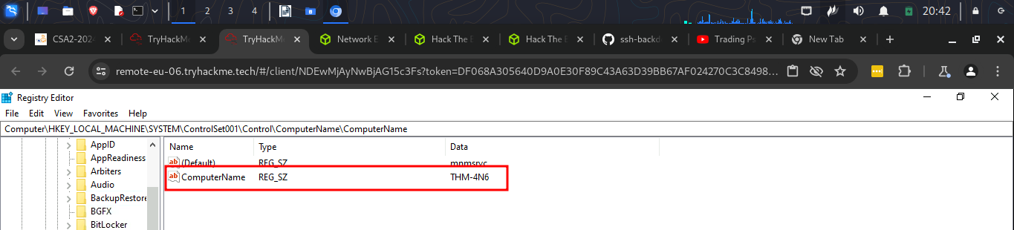

4.
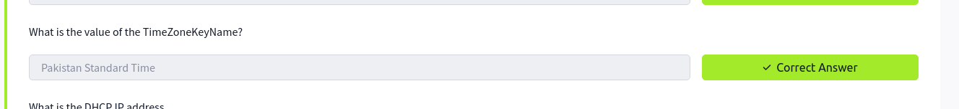
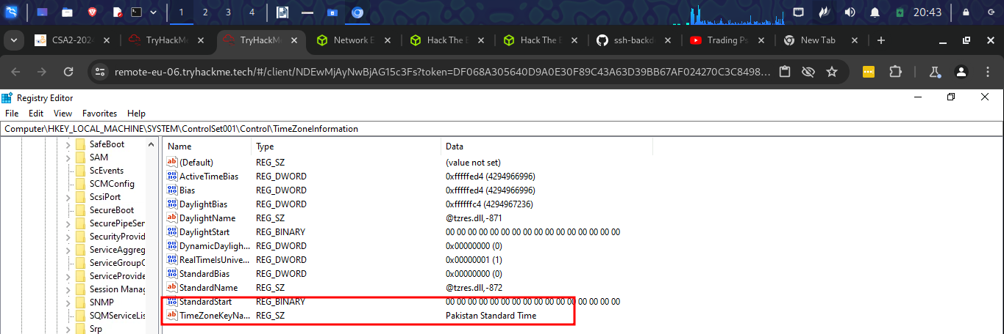
5.
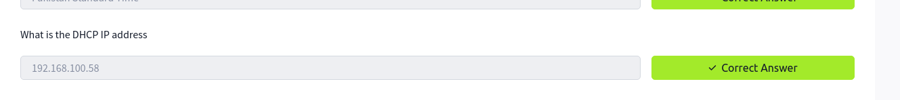
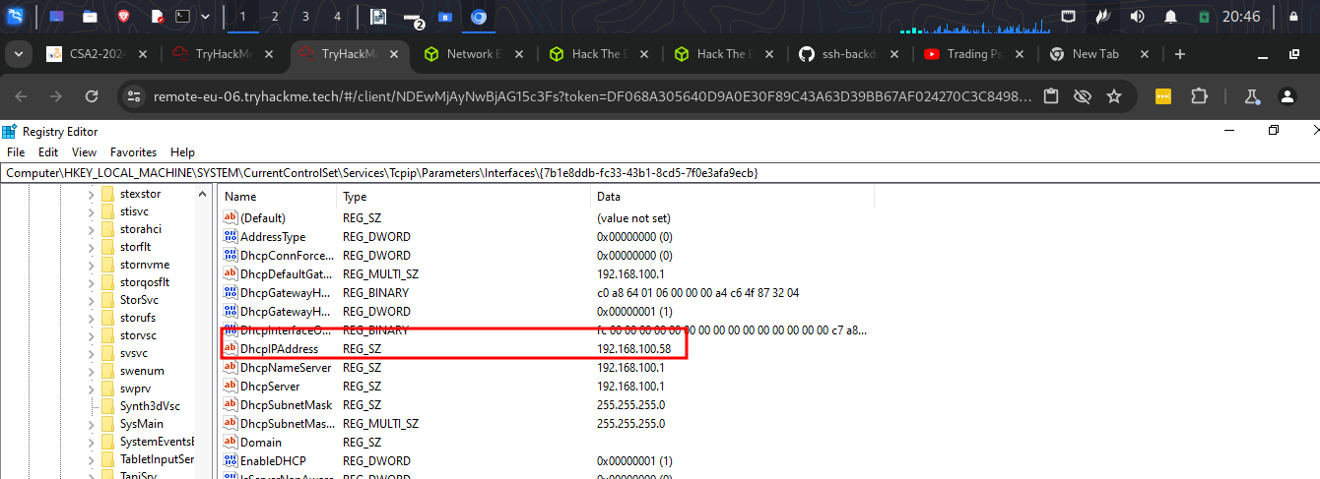
6.
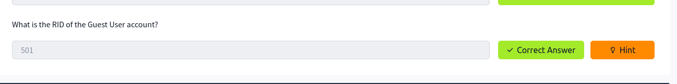
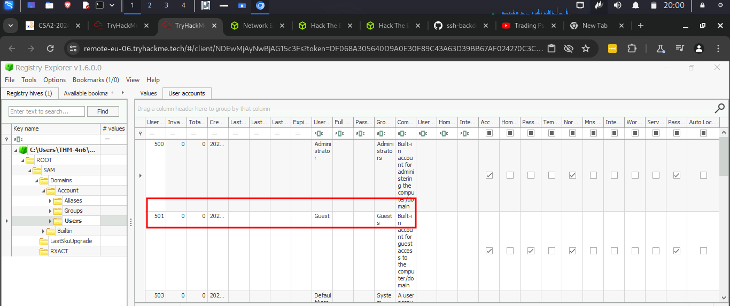

Usage or knowledge of files/folders
- Registry allows us to sort data contained in registry keys quickly, so recent document tab arranges the most recent used file at the top of the list (mru)
- Windows maintains a list of recently opened files for each user. It is stored in the NTUSER hive.
NTUSER.DAT\Software\microsot\windows\currentVersion\Explorer\RecentDocs
- Registry explorer allows us to sort data contained in registry keys quickly.
- Arranges files such that the most recent file is shown at the top of the list.
- There are extension keys like .pdf, .jpg which provide information about the lst used files of a specific file extension
- Microsoft office also provide list of recent accessed documents.
-

Questions
1.
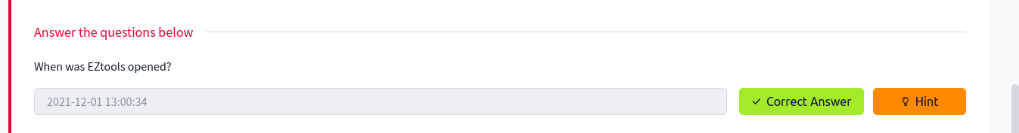
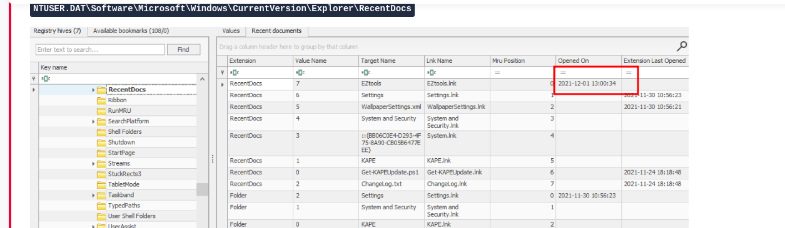

2.
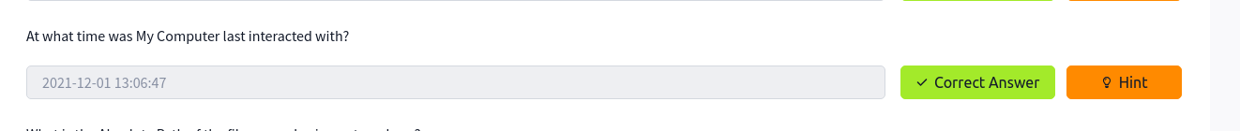
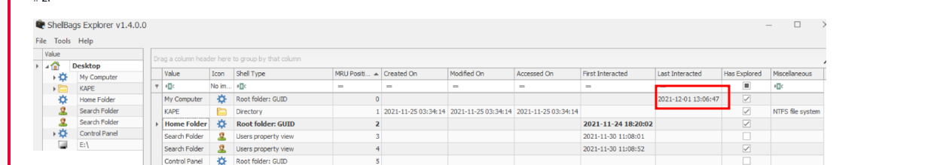

3.

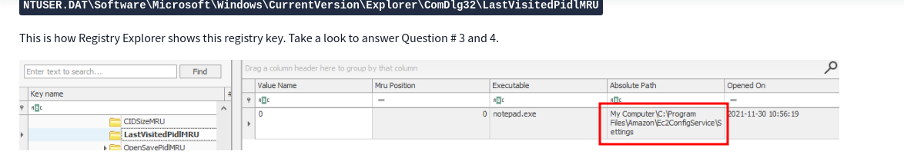

4.
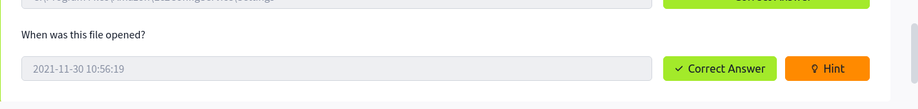
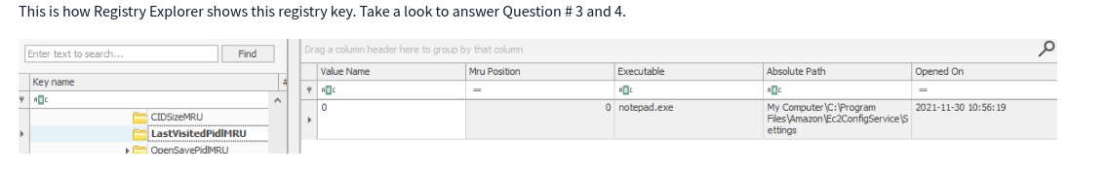

Evidence of Execution
- Windows keeps track of applications launched by the user using windows Explorer for statistical purposes in the user Assist registry keys
- ShimCache is a mechanism used to keep track of applications compatibility with OS and track all applications launched on the machine
- AmCache – perform similar functions like ShimCache
- BAM/DAM – Background Activity Monitor keeps a tab on the activity of background applications
- Desktop Activity Moderator is a part of windows that optimizes power consumption

Questions
1.
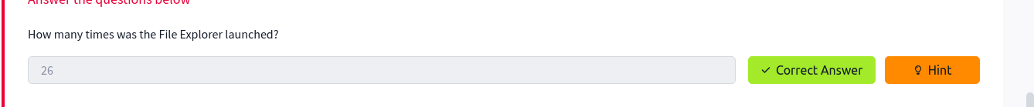
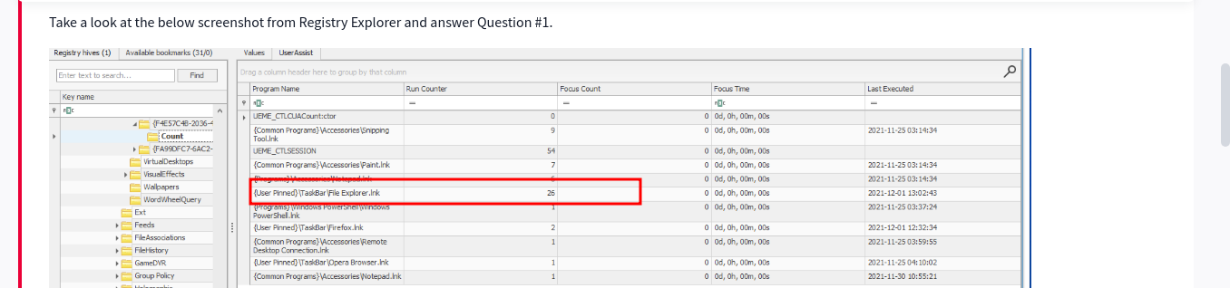
2.
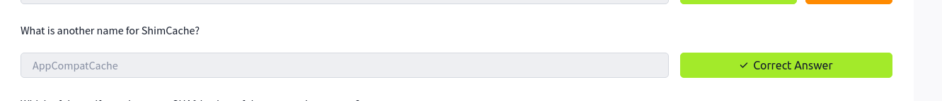

3.
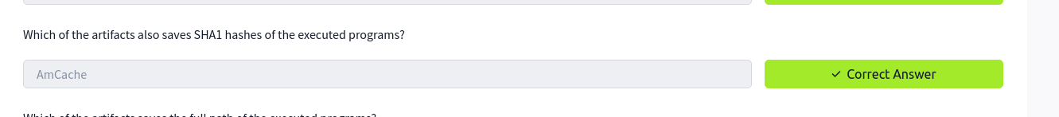
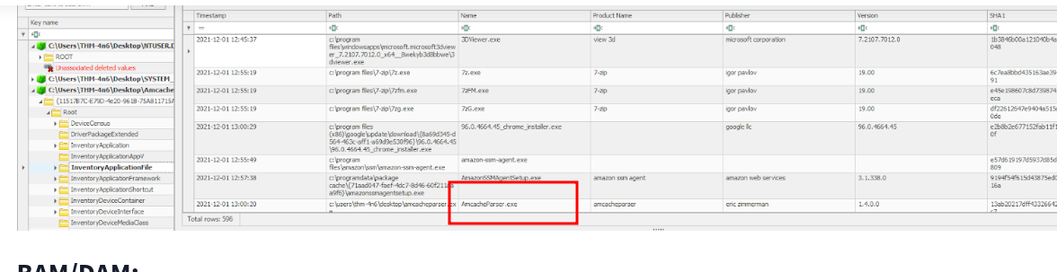

4.
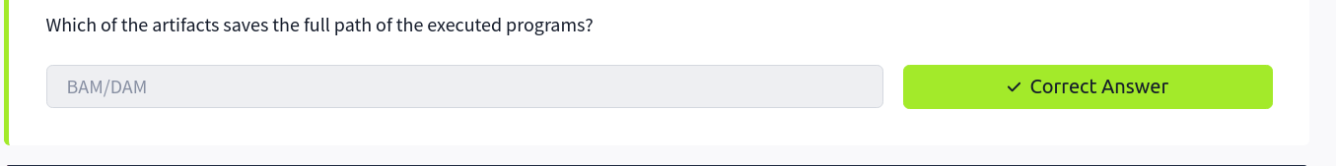

External Devices/USB devices forensics
- Usb keys plugged into a system are kept in system\currentcontrol\enum\usb

Questions
1.
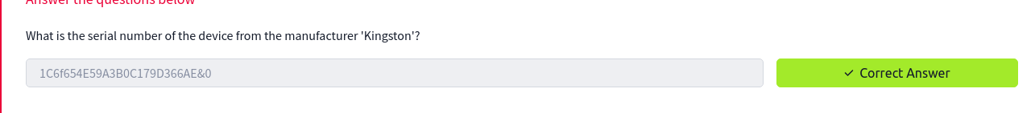

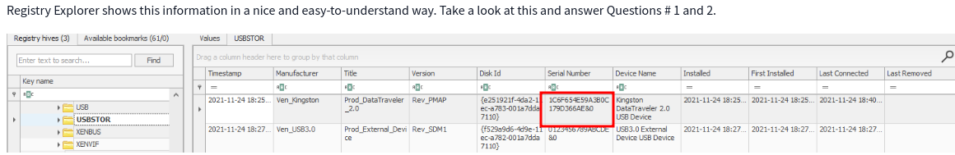
2.
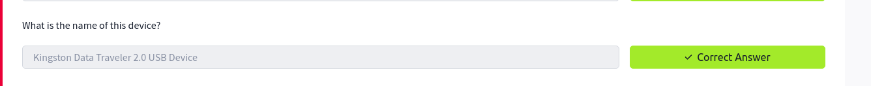
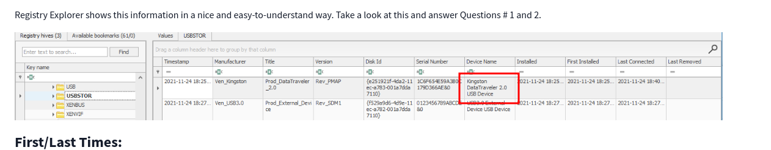

3.
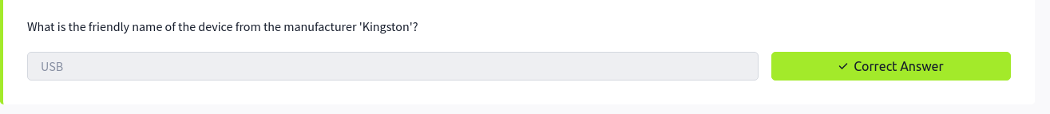
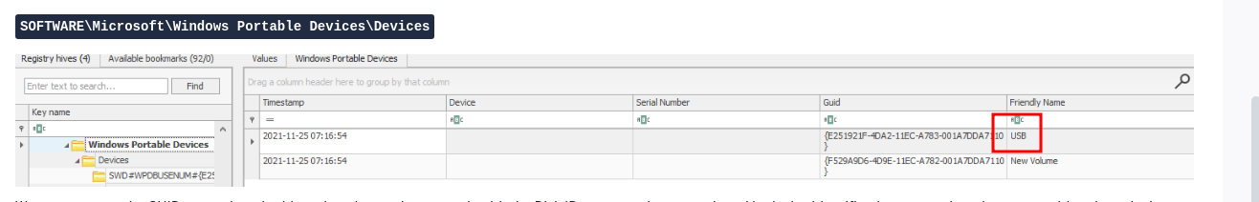

Hands on challenge
1.
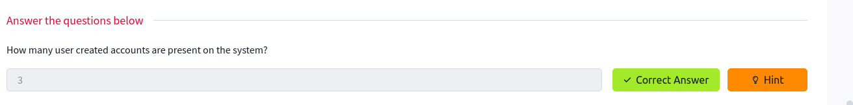
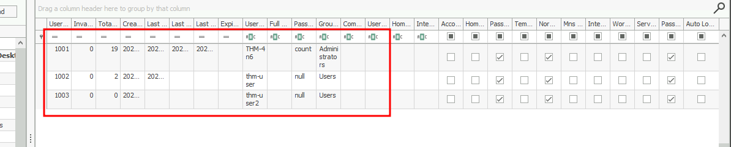

2.
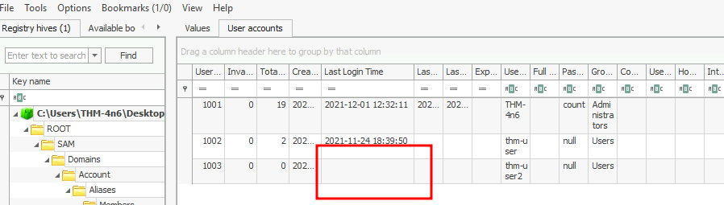

3.
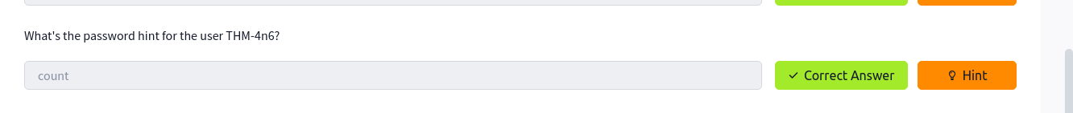
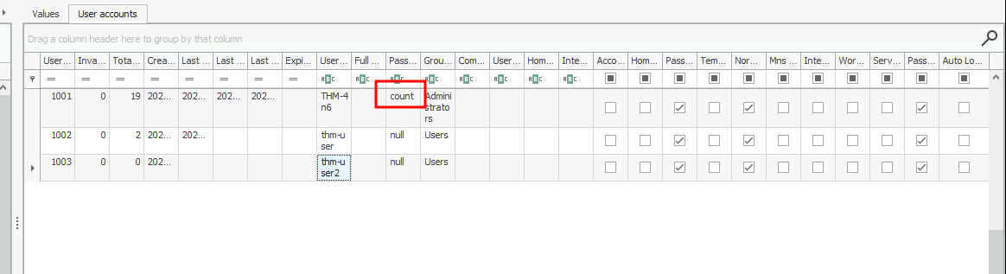

4.
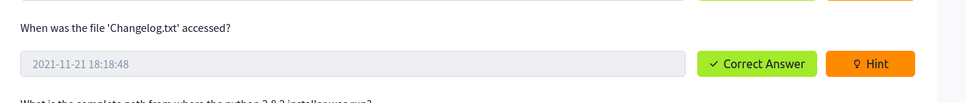
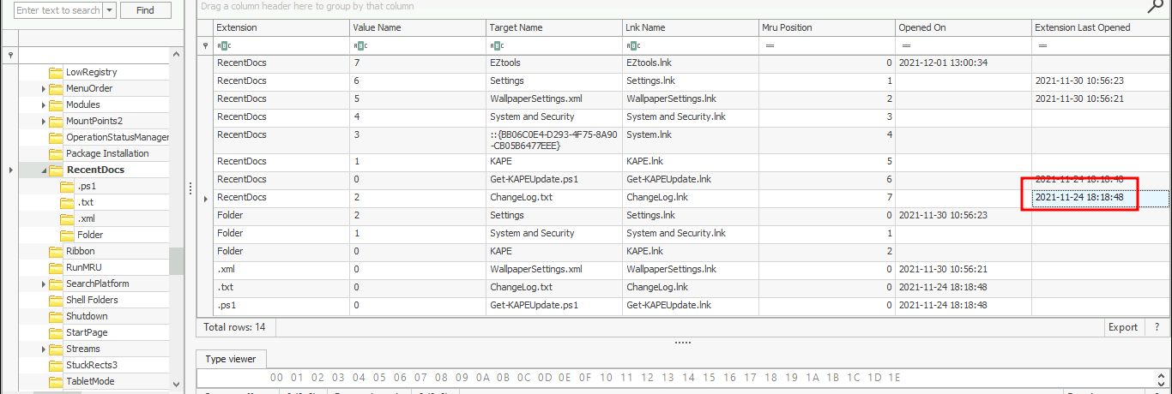

5.

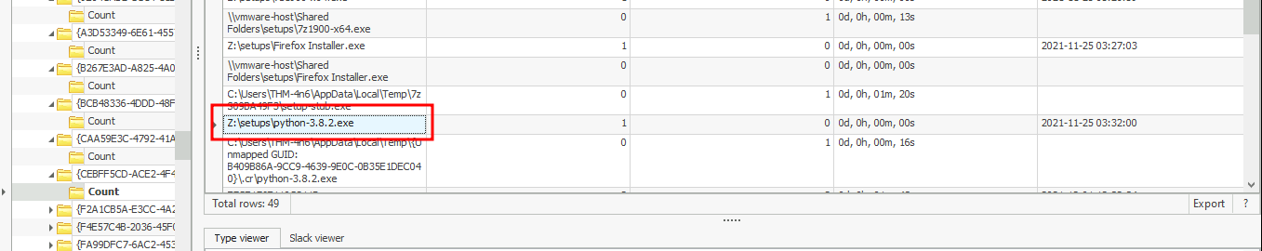

6.
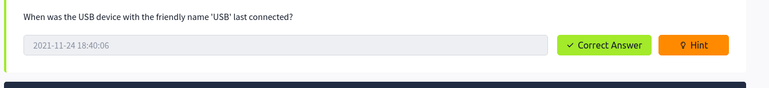
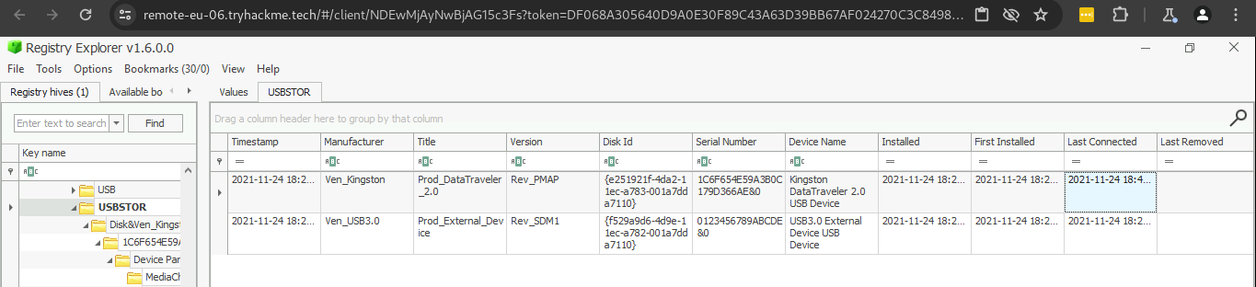

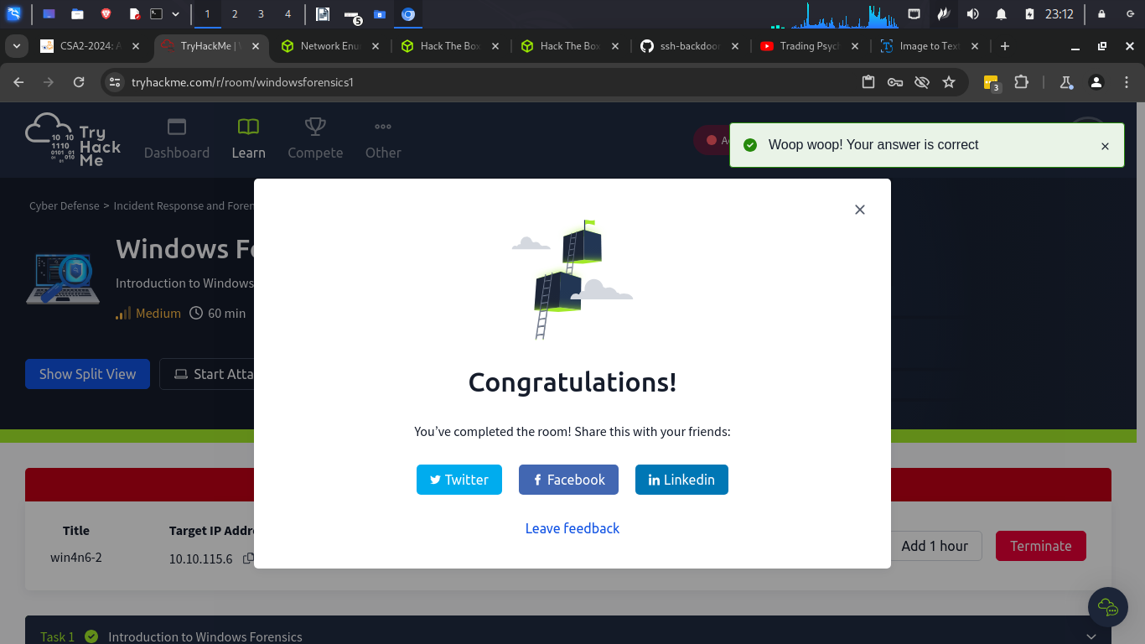

Conclusion
In this room I have learnt a lot about windows registry. I have learnt how to gather information about a windows computer and its users, to identify which files they used, Which program they ran and any external devices connected to them. I also downloaded the cheat sheet that I will be using to practice what I have learn.

